Week 4 Assignment-1

Q1.

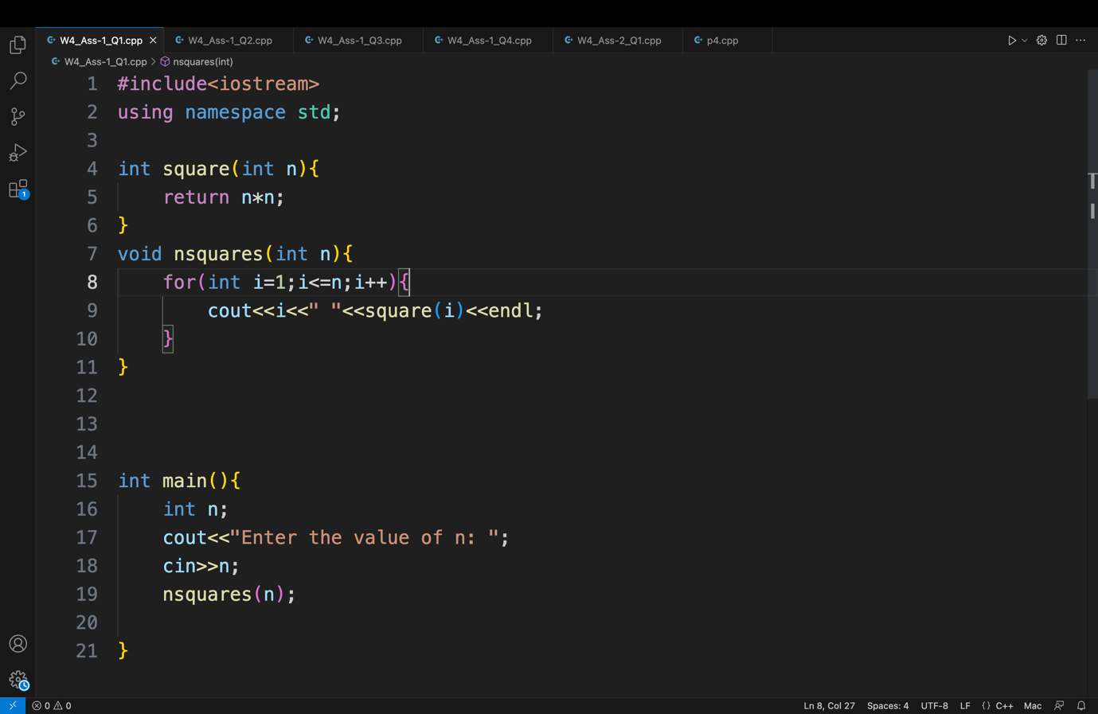

Q2

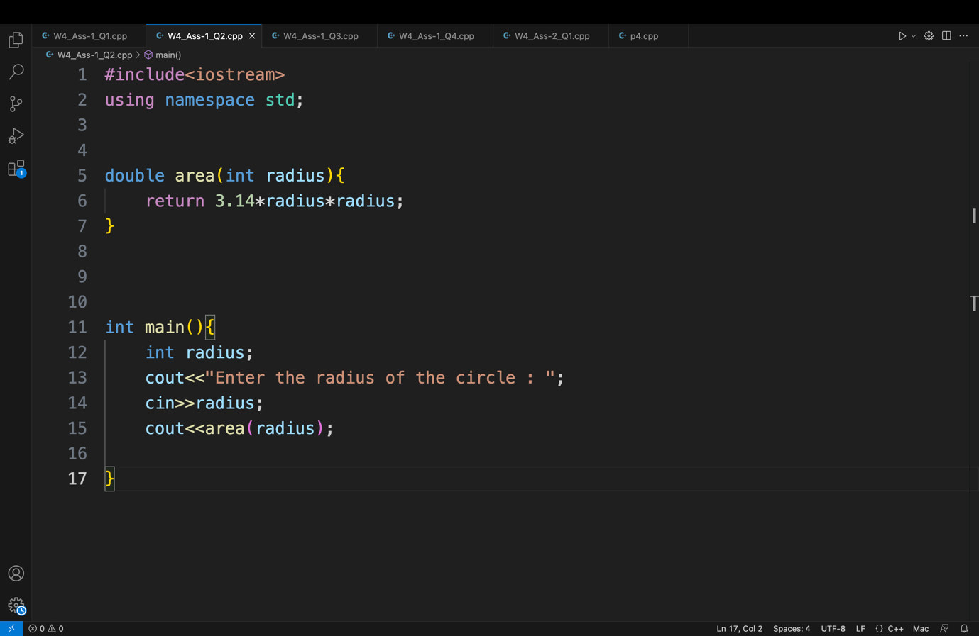

Q3.

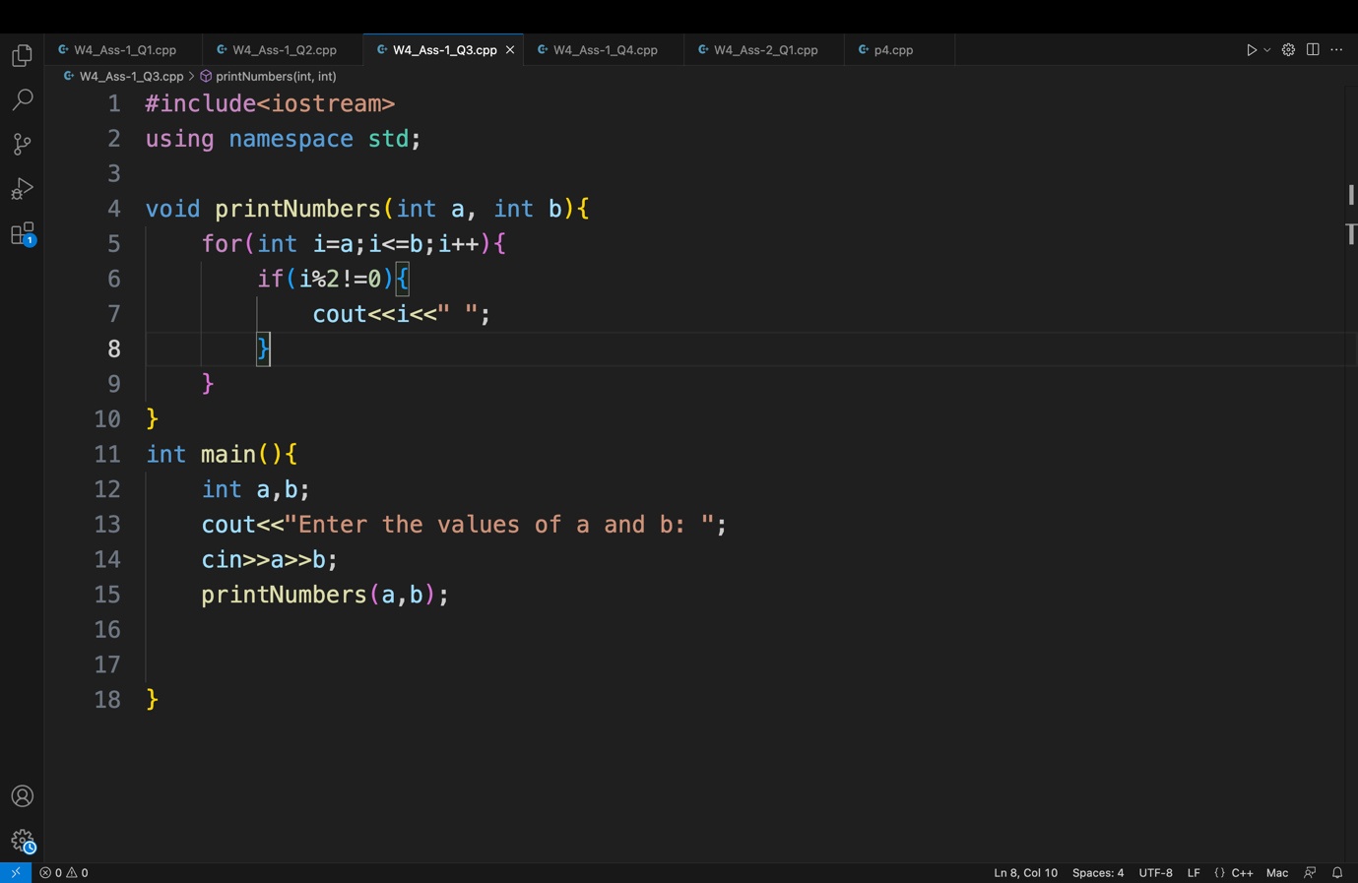

Q4.

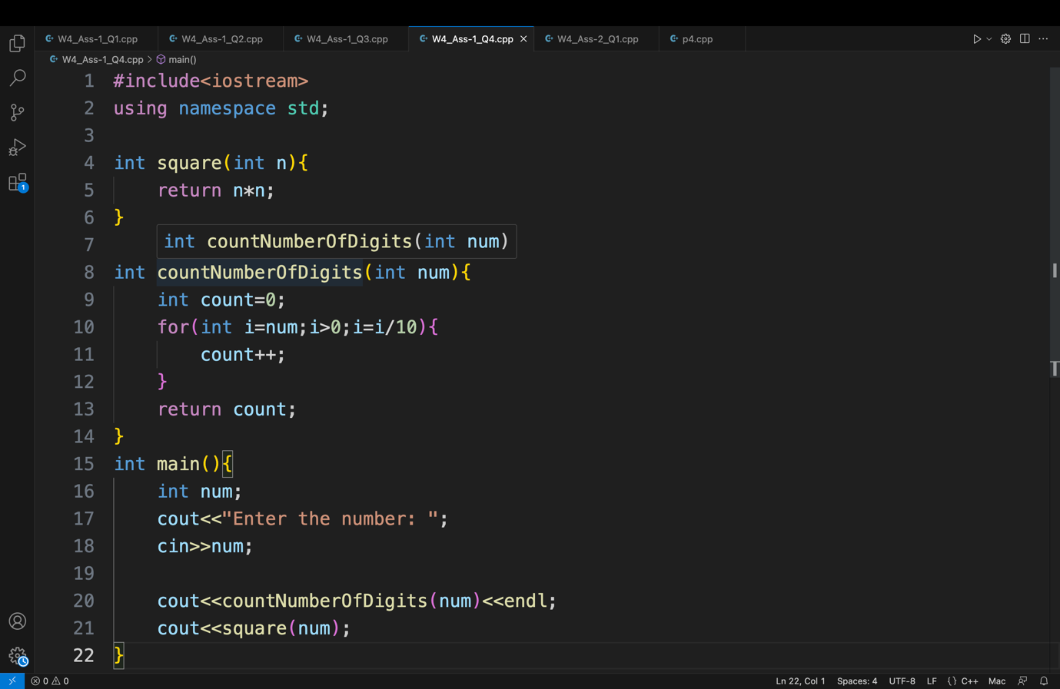

Q5.

1. The main function itself.

Q6.

True: We can call as many times a function as we want.

False: A function can have a void return type, which means return nothing. Although

it has to be clearly specified that the function is of void return type.

Q7.

The same function name can be used for different functions without any conflict if

and only if they either have different data types for arguments or different number

of arguments. Same function names cannot be used if functions differ only by their

return type because the compiler would not then know which function is to be used.